**INTRODUCTION**

|  |  |
| --- | --- |
| A picture of a winding road and trees  TUTORIAL 3  HTML & CCS | Nkhi Amukelani  INF3014F |

At Mu’s Books, we believe that every book holds a world of adventure, knowledge, and inspiration. Our bookstore was established in 2024 and our main goal is to build a literary haven where readers of all ages could discover stories that ignite their imagination. From bestselling novels to hidden literary gems, Mu’s Books is more than just a place to shop—it’s a community. Whether you’re a lifelong reader, an academic or just starting your audiobook journey, our website is here to guide you to your next great read. Our carefully curated collection spans across all genres, ensuring that there’s something special for everyone.

**DESIGN**

The two main colours I chose to use for the website are orange and white which I have made sure to keep consistent throughout the website. Additionally, I have used an orange font for all the major headings which is eye catching and appealing to the user so their experience of the website feels more interactive. Furthermore, the serif font in the style playfair display is aesthetic and decently sized to accommodate users of different eye strengths and to maintain readability. This playful yet sophisticated vibe aids the user to look through the website for more.

The website meets the Ohio State requirements for accessibility in that the pictures move when you hover on them for added interactivity and to show the user that they can interact with that image. Moreover, throughout the webpages, the buttons have the same design and colour to maintain consistency throughout the website. Lastly, I have included the March promotion that is currently running (at the bottom of our homepage) to inform users who would like to save money since books are already pricey. I put this on the home page so that it is one of the first few things that our customers see.

**USABILITY**

For usability, I added the navigation bar to allow the customers to navigate through the website easier by selecting the tab they would like to look through. I have added the bookstore logo and the shopping cart icon to the banner for further easy navigation since they are the most sought out features. Additionally, I have added a search bar for users who are looking for a specific book or accessory as well as for new users who might not have the time or patience to navigate the website. Furthermore, under each category there is a description of the types of products the category has, I have summarized this in a few words so as to not overwhelm the user but still provide them with all the information they need so they know which category to browse through. Lastly, I have added call to actions such as “add to cart”, “shop”, “Checkout”, etc. on each page to prompt the user to make a purchase. I have also ensured that all the buttons are formatted the same to maintain cohesion.

Ultimately, I have ensured that there is a clear description of each product in the store so that the user knows what to expect when they read the book or use the product. For added interactivity, the pictures lead to the relevant pages so if the user is too lazy to search or is unsure what book to buy, they can click on an image and they’ll be led to the relevant page.

# **References**

Emadamerho-Atori, N., 2025. *CSS Text Animations: 40 Creative Examples to Try.* [Online]   
Available at: https://prismic.io/blog/css-text-animations  
[Accessed 14 March 2025].

Exclusive Books, 2025. *Things Fall Apart Chinua Achebe.* [Online]   
Available at: https://exclusivebooks.co.za/products/9780141023380?_pos=1&_sid=157bc9b4a&_ss=r  
[Accessed 7 March 2025].

HostingerTutorials, 2025. *25 Examples of eCommerce Websites With Fantastic Designs for 2025.* [Online]   
Available at: https://www.hostinger.com/tutorials/ecommerce-website-examples#19_Notebook_Therapy  
[Accessed 14 March 2025].

mdn_, 2025. *CSS: Cascading Style Sheets.* [Online]   
Available at: https://developer.mozilla.org/en-US/docs/Web/CSS  
[Accessed 14 March 2025].

W3 Schools, 2025. *CSS Styling Images.* [Online]   
Available at: https://www.w3schools.com/css/css3_images.asp  
[Accessed 14 Month 2025].

WIX, 2025. *5 web design tips for an outstanding site.* [Online]   
Available at: https://www.wix.com/blog/5-design-tips-for-a-professional-site  
[Accessed 14 Month 2025].

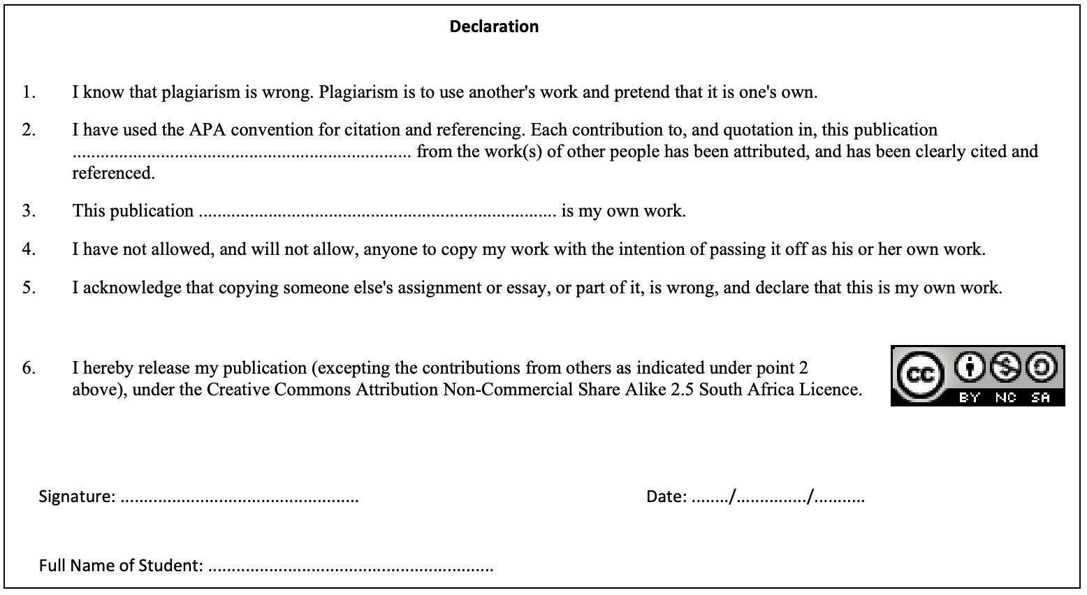

***Signature:*** *A. Nkhi*

***Name:*** *Amukelani Nkhi*

***Date:*** *14/03/2025*

***Referencing Convention:*** *Harvard*